Pupil Support Systems (Primary)
Addendum 2 for Behaviour and Relationships Policy

The DfE have not advised an update to this element of the school behaviour policy. However, it may be helpful to provide an overview of how support has been adapted and reviewed to address current needs. The actions below are suggestions only and should be personalised to the school.

We recognise that the current circumstances are exceptional. When our children return to school, our usual routines will be different to the norm and our classrooms may well look different.
We understand that some children have found the time at home without their usual routines and relationships difficult.
To help support our children we will adapt our pupil support systems.
We continue to make reasonable adjustments as necessary for our SEND children.

For all children:
- We will Increase the time we spend in school talking about our feelings and worries- using circle time, mindfulness sessions etc.
- We will continue to make the classroom experience as nurturing as possible for our children • We will provide opportunities for structured games to build self-esteem and confidence (whilst maintaining social distance)
- We will celebrate the successes of our children during the time they have been learning at home. This might be school home learning activities or learning a new skill at home
- All our staff will be alert to any changes in behaviour from our children and will speak to them individually to explore any possible concerns or worries. We will make contact with home if we observe any changes in behaviour
- When dealing with our children we use restorative practices at all times and will seek to calm and diffuse incidents of poor behaviour
- In their interactions with children, our staff will be mindful of the anxieties they may be facing and how this might affect their behaviour in school. We will provide additional support if this is needed
- We have placed links and resources to support positive mental health on our website. This may be helpful for parents. Let your class teacher or our Learning Mentor know if you feel that your child is finding things difficult
- We have an email address (accessed via our website) which our children can use as their worry box if they prefer not to approach us directly

For those children already in receipt of support prior to Covid -19.
As well as all the above support strategies, we will also:
- Review existing support plans to make sure they reflect current needs. We will adapt strategies as much as possible to enable our health and safety requirements to be met at all times
- Explicitly teach the new routines in class and use visual prompts when needed
- Provide as much consistency of experience as is possible
- We will continue to use strategies such as calm boxes and target cards when children will benefit from this
- We will direct support as needed to best assist our children. For some this may be that there is some 1:1 time with the adult from our bubble during lunchtime
- We will continue to work with other agencies to support children and families

For those children who have worries, concerns or changed behaviour on their return to school:
We have a dedicated area on our school website to signpost families to support ideas for use at home.
Our head teacher is available on the phone and via email if you wish to discuss any concerns. She is able to suggest some strategies that may be helpful at home and will be able to discuss your concerns with the class teacher.

Once we are clear around a fuller reopening of school, we will review our support offer again.

Additional resources for schools:
Self-esteem, confidence building and circle time activities:
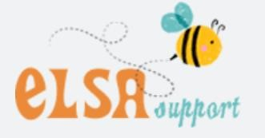
https://www.elsa-support.co.uk/downloads/category/elsa-resources/self-esteem/ https://www.elsa-support.co.uk/downloads/category/elsa-resources/strongfeelings/ https://www.elsa-support.co.uk/category/free-resources/coronavirus-support/
https://www.pshe-association.org.uk/curriculum-and-resources/resources/mental-health-andemotional-wellbeing-lesson-plans
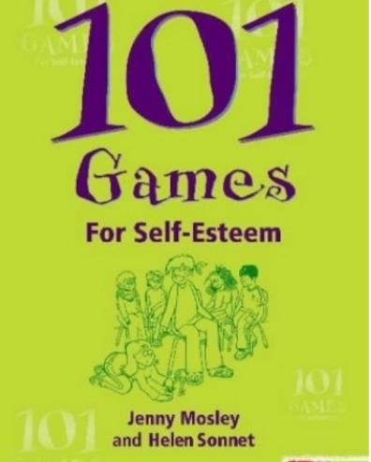

Zones of Self Regulation
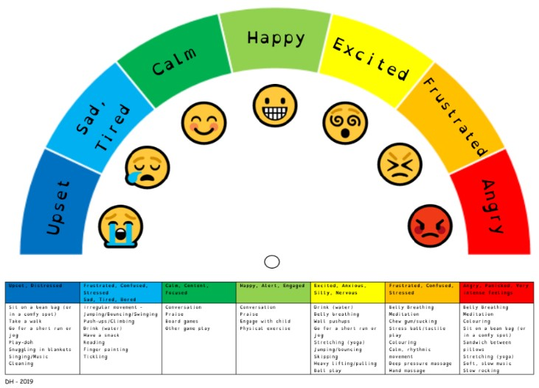

Resources for 1:1 conversations in school around worries, feelings and anxiety https://mentalhealth-uk.org/blog/the-stress-bucket/ https://www.healthierlsc.co.uk/application/files/1315/8463/7782/Worries_re_coronavirus.jpg http://www.innerworldwork.co.uk/wp-content/uploads/2017/04/Survival-In-School-PDF.pdf
http://www.innerworldwork.co.uk/wp-content/uploads/2017/04/What-survival-looks-like...-for-me-
2.pdf https://www.lancashiremind.org.uk/pages/154-support-for-children-young-people https://www.childline.org.uk/toolbox/calm-zone/ https://young.scot/get-informed/national/relaxation-exercises

Website resources for parents and carers
Signposting of
Mental Health advic

https://www.triplep-parenting.uk.net/uk-en/get-started/parenting-during-covid-19/ https://www.annafreud.org/on-my-mind/self-care/ https://www.annafreud.org/coronavirus-support/support-for-parents-and-carers/ https://www.healthyyoungmindslsc.co.uk/information/family-and-carers

