
Stalmine Primary School
Mill Lane, Stalmine, Poulton-Le-Fylde, Lancashire, FY6 0LR
Telephone: 01253 700284
Email: head@stalmine.lancs.sch.uk
Website: www.stalmineprimary.co.uk

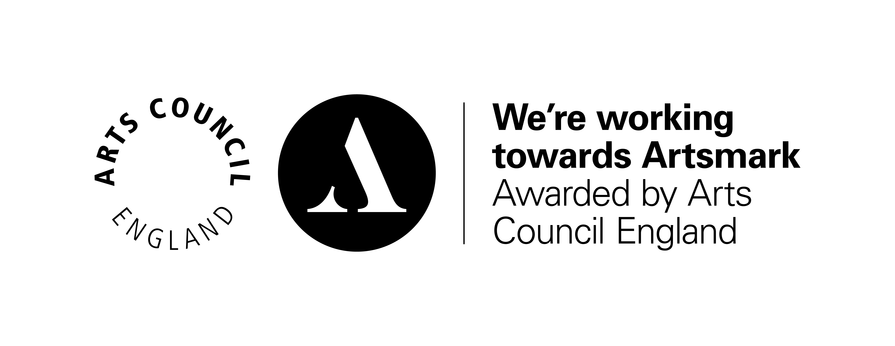
Head Teacher
Miss Hannah Binns

Dear Parents/Carers,

We are writing in further response to the Governments ambition to reopen schools next month and to inform you of the provisional plan here at Stalmine Primary School. It is important you understand that this remains a provisional plan only as events are changing rapidly and the government is yet to make their final decision.

As always, your child’s safety and well being are our primary concern. As we know the Covid-19 virus is in our communities and is spread easily from person to person.

Please note we cannot use the term ‘safe’ as we can only mitigate against the ‘risk’. Due to the nature of children, even though we will aim for 2 metre distancing, we cannot guarantee it at all times, particularly with our youngest children.

As mentioned in my previous letter, new government guidance is still being issued on a near daily basis and we may need to change and adapt plans at short notice.

Should the government’s key tests be met on Thursday 28th May, Stalmine Primary School’s plans for a Phased Wider Opening have been shared, discussed and agreed by the Senior Leadership Team, School Governors and the Local Authority.

The plan has been led by:

- Safeguarding: adult/pupil ratios have to be adhered to ensure the safety of pupils
- Minimising transmission risks, as much as we are able
- Staffing availability
- School environment
- Number of Key Worker pupils and Vulnerable pupils

The provisional plan is as follows:

Monday 1st June | Key Worker and vulnerable pupils return to school
Thursday 4th June | Reception pupils return to school  Due to staffing ratios and safeguarding, reception will be split into two separate groups led by two different teachers
Monday 8th June | Y6 pupils return to school

We are unable to open up to Nursery and Year 1 due to staffing and our ability to adhere to appropriate safeguarding ratios. This has been an incredibly difficult decision to make and I appreciate that many parents will be frustrated. The safeguarding and safety of our pupils has to be put first.

Each week we will review our current plans as part of our comprehensive risk management plan.

A more detailed plan, detailing drop off and pick up protocols and times has been provided separately, along with further details around parent, pupil and staff expectations.

As a headteacher this is another difficult letter to write. As a chair of governor’s and also as a parent, this is a difficult letter to write. We know we will have many pupils at home, who are desperate to see their friends again and we agree wholeheartedly that school is the right place for our pupils. But this can only be when it is safe for them, safe for us and safe for you too.

For those pupils who are still at home, home learning will still be provided. Ms Townsend will still be reading Roald Dahl to her class using the most fantastic of voices, Ms Clarke will still be sharing nursery rhymes for Nursery children at home; Mr McShane will still be setting creative activities such as the photography and Mrs Parkinson will still be reading her class story to Class 3. Those teachers now in school full time may not be able to answer messages or comment on work as quickly as they have done in the past, but they still absolutely care about those still at home and the work that they are doing. Ms Townsend will be available for those in Nursery and Class 1 and Miss Binns will be available for those in Y3-5 for parents to message, should they need to.

In these most unusual times we are doing our very best to adhere to government guidance and to minimise risk as much as is possible. We anticipate that week by week we will continue to receive new information and that we all need to embrace a fluid and flexible approach to the situation that we find ourselves in. We appreciate all of your continued support during this unprecedented time.

Take care,

Miss Binns Mrs Hughes-Hutchings
Head teacher Chair of Governors

