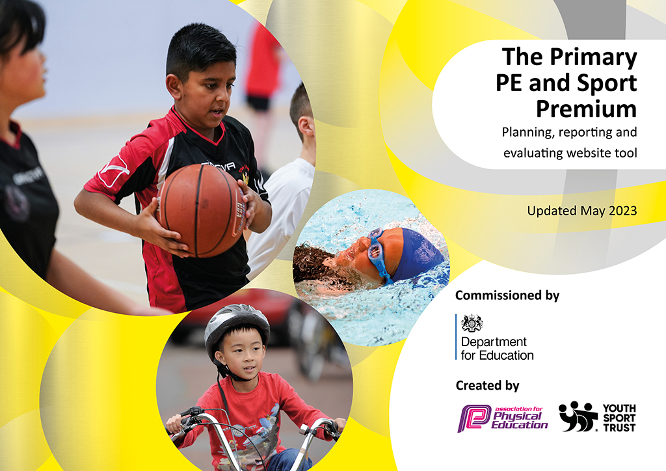

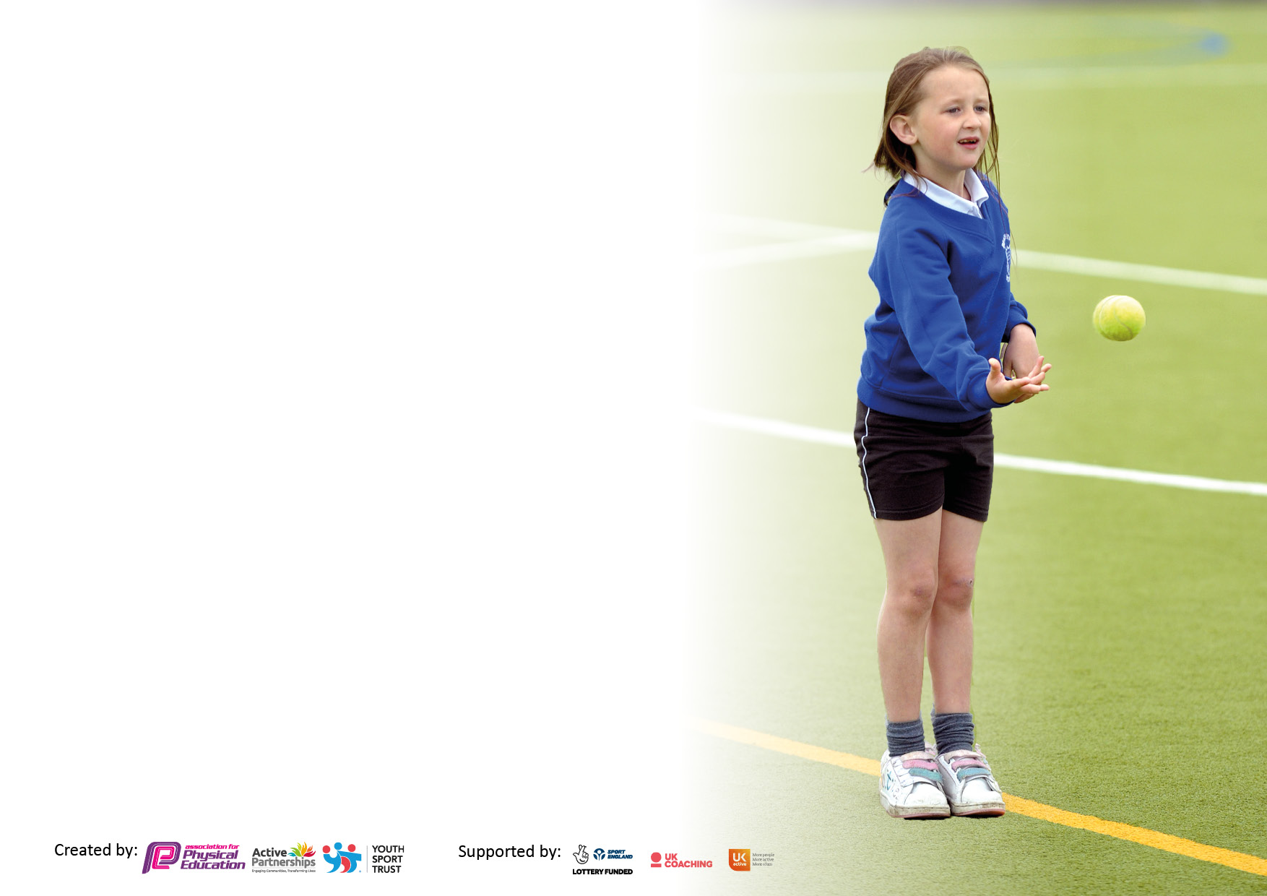

It is important that your grant is used effectively and based on school need. The Education Inspection Framework makes clear there will be a focus on ‘whether leaders and those responsible for governors all understand their respective roles and perform these in a way that enhances the effectiveness of the school’.
Under the Quality of Education Ofsted inspectors consider:
Intent - Curriculum design, coverage and appropriateness
Implementation - Curriculum delivery, Teaching (pedagogy) and Assessment
Impact - Attainment and progress

To assist schools with common transferable language this template has been developed to utilise the same three headings which should make your plans easily transferable between working documents.
Schools must use the funding to make additional and sustainable improvements to the quality of Physical Education, School Sport and Physical Activity (PESSPA) they offer. This means that you should use the Primary PE and sport premium to:
- Develop or add to the PESSPA activities that your school already offer
- Build capacity and capability within the school to ensure that improvements made now will benefit pupils joining the school in future years
- The Primary PE and sport premium should not be used to fund capital spend projects; the school’s budget should fund these.

Please visit gov.uk for the revised DfE guidance including the5keyindicatorsacrosswhichschoolsshoulddemonstrate an improvement. This document will help you to review your provision and to report your spend. DfE encourages schools to use this template as an effective way of meeting the reporting requirements of the Primary PE and Sport Premium.

We recommend you start by reflecting on the impact of current provision and reviewing the previous spend.
Schools are required to publish details of how they spend this funding, including any under-spend from 2022/2023, as well as on the impact it has on pupils’ PE and sport participation and attainment. The funding should be spent by 31st July but the DfE has stated that there will be no clawback of any unspent money so this can be carried forward into 2023/24.
We recommend regularly updating the table and publishing it on your website throughout the year. This
evidences your ongoing self-evaluation of how you are using the funding to secure maximum,
sustainable impact. Final copy must be posted on your website by the end of the academic year and no
later than the 31st July 2023. To see an example of how to complete the table please click HERE.

Support for review and reflection - considering the 5 key indicators from DfE, what development needs are a priority for your setting and your students now and why? Use the space below to reflect on previous spend, identify current need and priorities for the future.

Key achievements to date: | Areas for further improvement and baseline evidence of need:
- New Trim Trail installed in Summer term 2023 and is fit for purpose and being utilized by all pupils in school.  - Specialist in house P.E teacher delivering P.E lessons across school Excellence and enjoyment of PE has risen.  - Every child across school YR-Y6 has the opportunity to access at least 6 weeks of swimming lessons in curriculum P.E. (KS2 pupils accessing up to 12 weeks). Top up lessons available for Y6 in the final term if required.  - New P.E app has helped to assess pupil progress in P.E across school and move pupils forward with their skills across the P.E curriculum.  - Boys WON the Over Wyre U11 football competition against our neighboring schools.  - Updated resources in school to be used for Curriculum P.E.  - Y6 outward bound 2-day experience in the Lake District in the Summer term. | - To enter further competitions against other schools to broaden  - Secured extra-curricular sports sessions with Fleetwood Town Community x2 evenings per week from Sept 2023 and Judo Education x1 evening a week to run across the academic year 2023-24 providing a range of sports that change on termly rota. (Free clubs) for pupils  - experiences of a range of sports for pupils across age groups.  - Provide opportunities for all pupils to access extra-curricular clubs that offer a range of differing sporting opportunities throughout the school year. This will include opportunities for both KS1 & KS2 pupils.  - Further continue to develop staff CPD and excellence and enjoyment of PE by utilizing skills of specialist sports coaches with a particular focus on Dance.  - Build on commitment to pupils being engaged in physical activity beyond curriculum P.E. – Daily Mile, playtime games, playtime pals, playtime equipment to engage pupils in outdoor activity to encourage being active at playtime.  - Further develop forest school area at the far end of school to build on the existing potential for ‘Forest School’ activities within school curriculum time and the weekly extra-curricular club led by external Forest School Leader. Opportunities to use the facility for further aspects of the outdoor and adventurous curriculum in P.E.  - Cycling proficiency booked in for the eldest pupils in school for 2024

Total amount carried over from 2021/22 | £23,160 (Low spend due to Covid, lack of comps, clubs, pool closure etc…
Total amount allocated for 2021/22 | £16,000
How much (if any) do you intend to carry over from this total fund into 2022/23? | £12,000 -15,000
Total amount allocated for 2022/23 | £16,660
Total amount of funding for 2022/23. Ideally should be spent and reported on by 31st July 2023. | £39,820

Swimming Data
Please report on your Swimming Data below.

Meeting national curriculum requirements for swimming and water safety | Please complete all of the below*:
What percentage of your current Year 6 cohort swim competently, confidently and proficiently over a distance of at least 25 metres? | (Summer 2023 – 89% of pupils in Y6)
What percentage of your current Year 6 cohort use a range of strokes effectively [for example, front crawl, backstroke and breaststroke]? | (Summer 2023 – 89% of pupils in Y6)
What percentage of your current Year 6 cohort perform safe self-rescue in different water-based situations? | (Summer 2023 – 89% of pupils in Y6)
Schools can choose to use the Primary PE and Sport Premium to provide additional provision for swimming but this must be for activity over and above the national curriculum requirements. Have you used it in this way? | Yes- all pupils in all year groups, including Reception/Nursery have swimming lessons as part of their PE curriculum.

Action Plan and Budget Tracking
Capture your intended annual spend against the 5 key indicators. Clarify the success criteria and evidence of impact that you intend to measure to evaluate for students today and for the future.

Academic Year: 2022/23 | Total fund allocated:  £39820 (2022-23) | Date Updated: Summer 2023
Key indicator 1: The engagement of all pupils in regular physical activity – Chief Medical Officer guidelines recommend that primary school children undertake at least 30 minutes of physical activity a day in school

INTENTIONS | IMPLEMENTATION  Actions to achieve: | Funding allocated: | Evidence and IMPACT | Sustainability and suggested next steps:
Children given the opportunity to participate in the Daily Mile on a daily basis.  Updating playground play equipment across the school year. | PE lead to monitor the level of participation throughout school.  Encourage pupils at playtime to be actively engaged in climbing, balance, strength activities. | -  £2000 | Children are increasing their stamina and fitness levels are increasing.  Pupils actively engaged in games each playtime | To secure funding for a purpose built Daily Mile track so the children can undertake this activity even in bad weather.  Monitoring of equipment being fit for purpose. Collection of equipment during adverse weather/winter months.
Key indicator 2: The profile of PE and sport being raised across the school as a tool for whole school improvement
School focus with clarity on intended impact on pupils: | Actions to achieve: | Funding allocated: | Evidence and impact: | Sustainability and suggested next steps:
Release P.E subjects lead to monitor effectiveness of curriculum P.E across school.  Extra curriculum resources for P.E | Ensure good quality of P.E delivered across school.  Ensure good quality of P.E delivered across school. | £100-500 supply cover if required to release P.E lead  £3000 | PE lead to monitor staff competency and confidence through entry and exit questionnaires.  Pupils provided with a better variety of equipment. More enthusiasm. Improved skill. Improved teaching for pupils with improved variety of resources | Cost is a factor but CPD will ensure staff are well equipped to deliver high quality sessions.  New equipment to replace old. If looked after will last a number of years with appropriate re-use.

Key indicator 3: Increased confidence, knowledge and skills of all staff in teaching PE and sport
School focus with clarity on intended  impact on pupils: | Actions to achieve: | Funding  allocated: | Evidence and impact: | Sustainability and suggested  next steps:
Professional coaches employed to provide both in house sessions and after school clubs. Staff CPD ongoing with the coaches. | Professional advice/support for staff in school from external professional sports coaches to help deliver aspects of P.E curriculum | Course fees as of when required.  (Max £1000)  Extra sessions by partnership trust to deliver curriculum P.E for pupils and CPD for staff where identified as needed. |  | Cost is a factor but CPD will ensure staff are well equipped to deliver high quality sessions. Excellence and enjoyment is high amongst all pupils.
Key indicator 4: Broader experience of a range of sports and activities offered to all pupils
School focus with clarity on intended  impact on pupils: | Actions to achieve: | Funding  allocated: | Evidence and impact: | Sustainability and suggested  next steps:
Agreed contract with Judo Education to run a 2 hour weekly club across the academic year. (Fencing/ archery)  Agreed contract with external provider to run ‘Forest School club’ 2 hours weekly across the academic year.  Yoga sessions 1-2 hours a week  Healthy Heads project with local high school  Y6 end of year experience days - 2day trip to the Lake district to participate in OAA activities on water and land  Swimming experience for every class in school YR-Y6 | Professional coaching sessions in school providing different opportunities with new less traditional sports  Encouraging pupils to engage more with the outdoor environment post Covid. Make use of excellent outdoor facilities around school grounds  Healthy minds, mental health, relaxation  Healthy minds, mental health, relaxation  Water confidence for pupils at an early age. | £3000  £3000  £2000  £2000  £1500 including transport  £5000 | Feedback from pupils / parents on the sessions being run.  Feedback from pupils / parents on the sessions being run.  Feedback from pupils / parents on the sessions being run.  Attitudes of pupils: building resilience and determination  Pupils become water confident from a younger age with an expectation for  TARGET-  80%+ of pupils to be at age expected level for water safety at Y6  *(100% of pupils that have been in school from YR) | Ensure funding allocation is protected to allow partnerships to continue in the future.
Key indicator 5: Increased participation in competitive sport |  |  |  | Percentage of total allocation:
School focus with clarity on intended  impact on pupils: | Actions to achieve: | Funding  allocated: | Evidence and impact: | Sustainability and suggested  next steps:
The school enrolls onto the Wyre School Sports partnership | Enroll school teams in various competitions and offer a wider range of after school sports activities to cater for all abilities.  Explore the use of the more unusual sports.  Engage in the Wyre Sports Partnership to ensure we sign up to a range of tournaments and competitions for our pupils | Transport -£500-1000 across the year | Uptake in events by pupils.  Success of pupils in competitions.  *Boys football team were Wyre Primary schools’ champions in 2023. | Ensure money is set aside next academic year to enroll into the Wyre Schools Sports Partnership giving access to a multitude of sporting competitions across the year.

